CAS outputs and its interpretations - constrained optimisation
Ondřej Marvan, 477001
Cause first, then effect. So, lets start with what government did and then happened because of that.
- The Policy: What the Government Did
This graph descrbes what government did.

  - Graph for Tax Structure
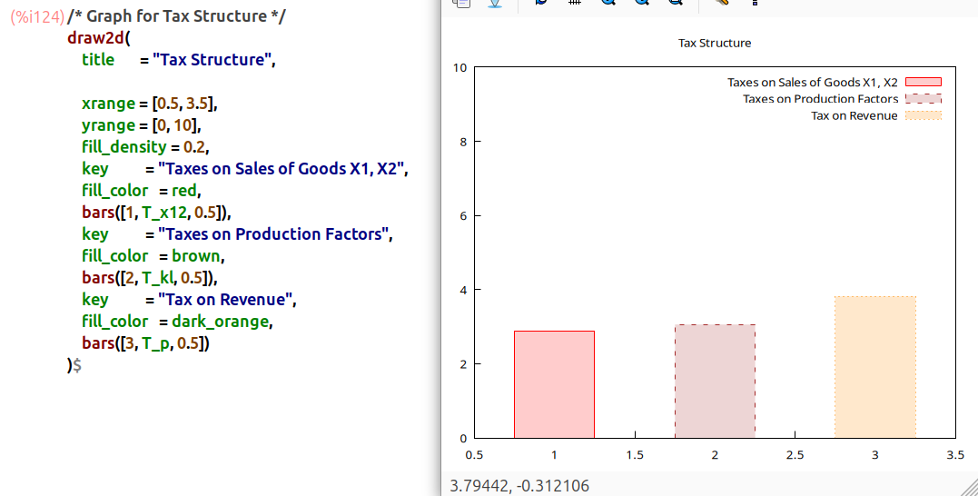
Interpretation: This is where the government is getting its money. It's using three different taxes. The taxes on "Sales of Goods" (red) and "Production Factors" (brown) are pretty similar. The biggest one is the "Tax on Revenue" (orange), which clearly brings in the most cash.

  - Graph for Subsidies
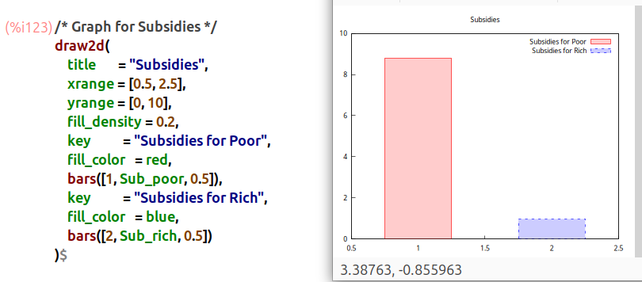
Interpretation: This is where all that tax money is going. The "Subsidies for Poor" (red bar) is massive, way up near 9. The "Subsidies for Rich" (blue bar) is tiny, down around 1. So, the plan is simple: tax everyone (especially on revenue) and give almost all of it to the poor.

- The Market Reaction: How Prices Changed
Okay, so the government jumped in. How did the market react? Let's look at prices.

  - Graph for Changes in Price p1
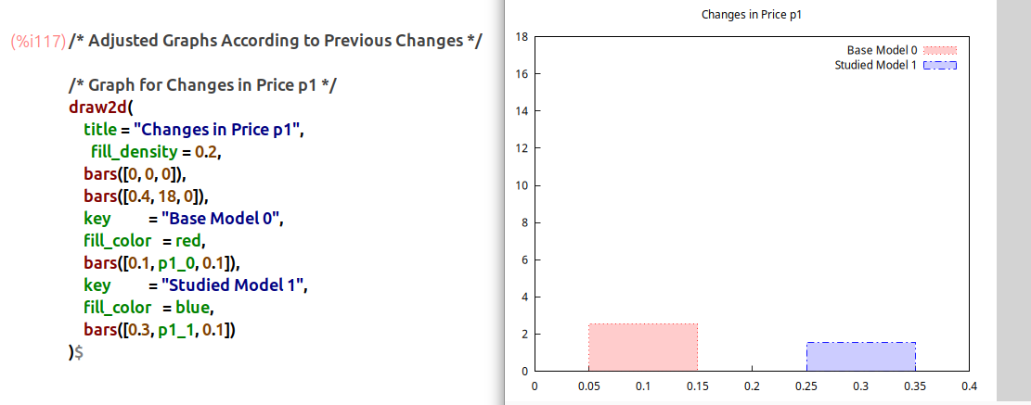
Interpretation: Look at the price for Good X1. The old price ("Base Model 0") is the red bar. The new price ("Studied Model 1") is the blue bar. The new price is clearly lower. The policy made Good X1 cheaper.

  - Graph for Changes in Price p2
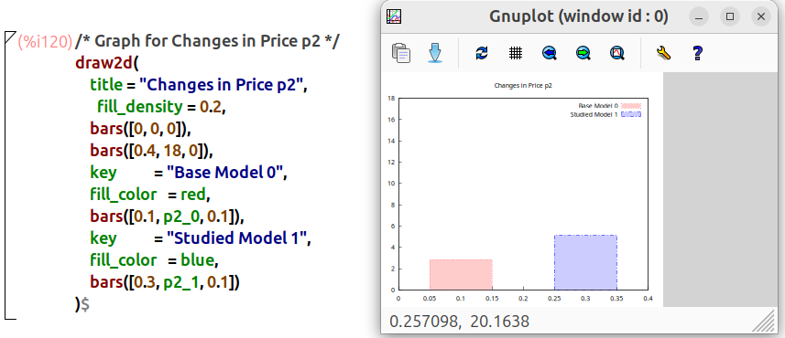
Interpretation: Now for Good X2. The new price (blue bar) is way taller than the old one (red bar). The policy made Good X2 a lot more expensive.

  - Graph for Changes in Interest Rates
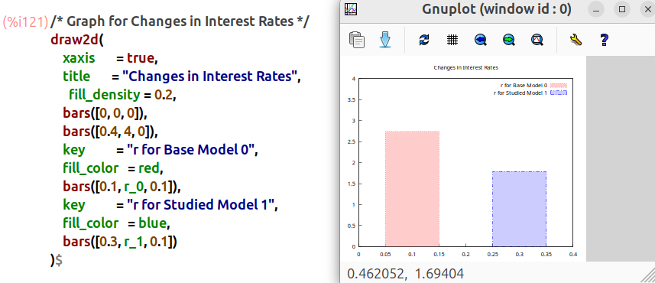
Interpretation: This one is the interest rate (r), which is just the "price" of capital. The new rate (blue bar) is shorter than the old one (red bar). The interest rate went down.
- The People's Reaction: How Consumption Changed
We have new prices (X1 cheap, X2 expensive) and new incomes (poor are richer, rich are poorer). How did people change their shopping habits?

  - Change in... Goods X1 and X2 (poor)
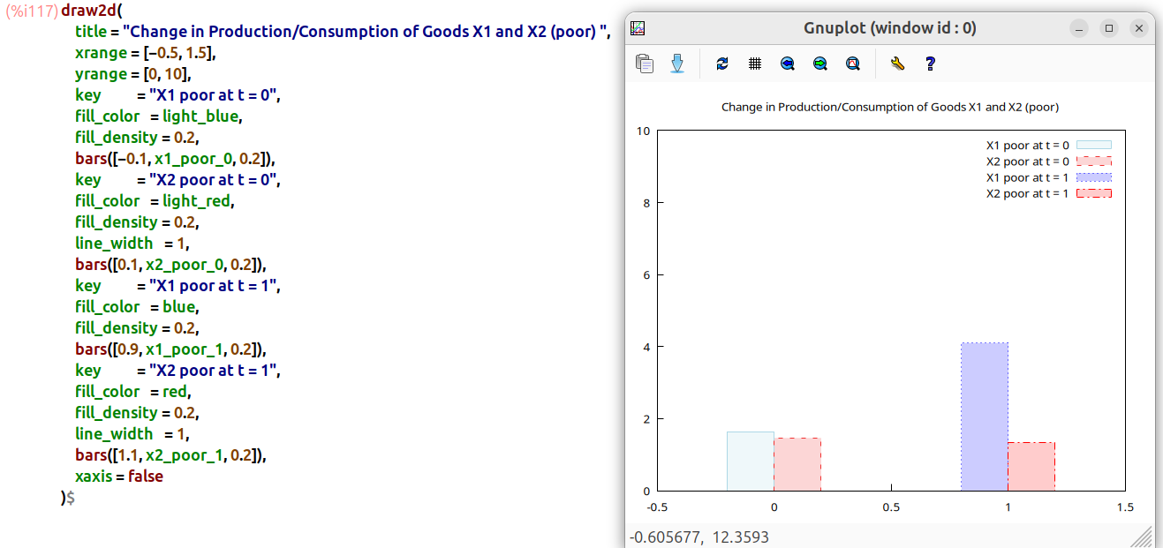
Interpretation: This graph shows the poor household.
  - Good X1 (blue): They are buying way more of Good X1. The "t=1" bar is much taller than "t=0". This makes sense: it's cheaper, and they have more money from the subsidy.
  - Good X2 (red): They're buying a little less of Good X2. No surprise, since p2 got so expensive.

  - Change in... Goods X1 and X2 (rich)
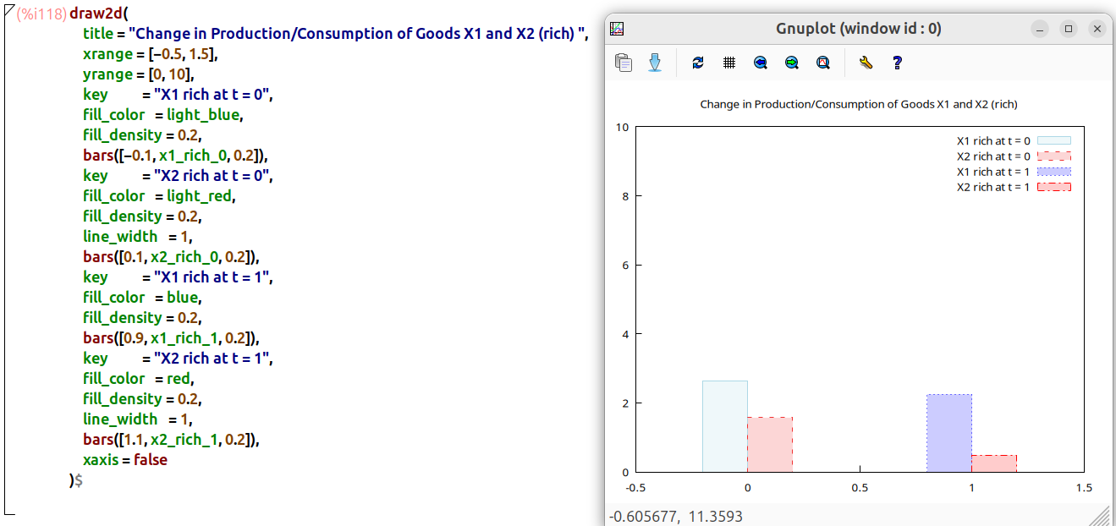
Interpretation: This graph shows the rich household.
  - They are buying less of Good X1 (blue bar "t=1" is shorter).
  - They are buying way less of Good X2 (red bar "t=1" is much shorter).
  - They got taxed and only got a tiny subsidy, so their income is down. They just buy less of everything.

- The Economy's Reaction: Total Production

  - Change in Production/Consumption of Goods X1 and X2
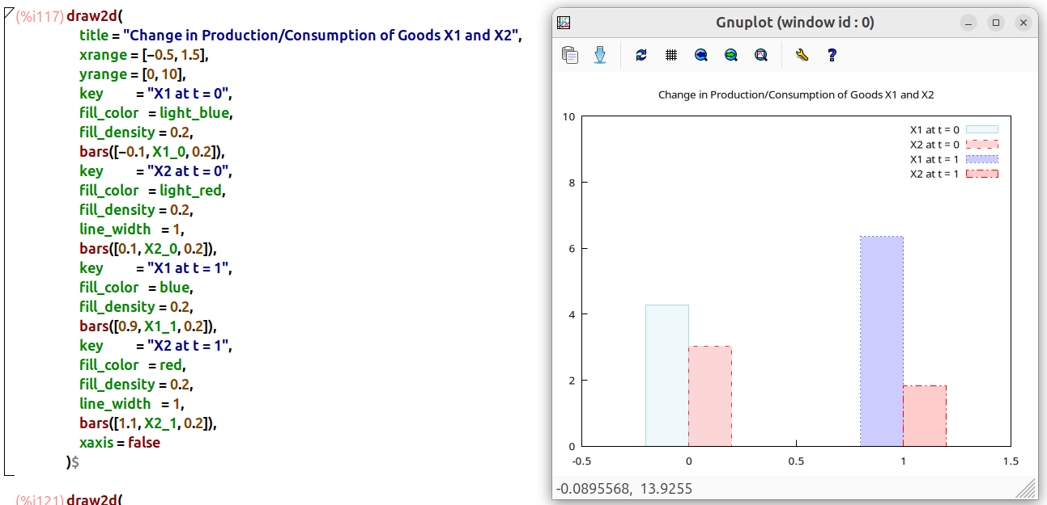
Interpretation: This graph just adds the poor and rich households together to get the big picture.
  - Good X1 (blue): The poor household's huge increase in demand outweighed the rich's small decrease. Total production of X1 went up.
  - Good X2 (red): Both groups bought less. Total production of X2 went down.

- The Final Verdict: Who Won and Who Lost
Was the policy a "success"?

  - Graph for Equivalent Variation (EV)
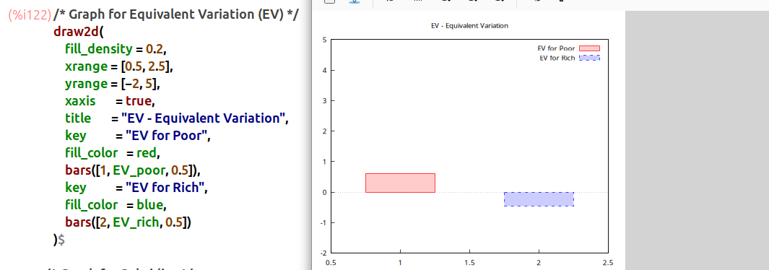

Interpretation: This graph tells us who is happier or sadder.
  - "EV for Poor" (red bar): This is positive (it's above the 0 line). This means the poor household is better off. The giant subsidy they got was more than enough to cover the higher price of Good X2.
  - "EV for Rich" (blue bar): This is negative (below the 0 line). This means the rich household is worse off. The taxes hit them hard, and the small subsidy didn't help.
Conclusion: The policy was a success at redistribution. It made the poor better off at the expense of the rich.

